PIVOT TRADING WITH TDI
TS (Thread Starter) by: Mr. Davit
Link: http://www.forexfactory.com
Pairs Trade: UC AC EA AU GU NU AN EU
TF (Time Frame): 15m (minimum), bigger TF works as well.
Indicators use: refer to the link above
ADR ADR is just a tool to let you know if pair is overstretched on daily range. When that happens likelihood of reversal is great and when confluences with pivots creates great opportunities. Emphasis is always on PA because often when pair overshoots its likely that something major happened like rate cut or other fundamental factors so you must check why it overshot in the first place.
Download all the indicators and template from the link above.
For Indicator saved the file where your MT4 file located, search for MQL4 folder, and paste to subfolder: Indicator.
For template file save in template folder, where your MT4 file is located.
Here’s How to Trade the Pivot with TDI:
Here is how to trade pivots (TS use weekly pivot, not daily Pivot..)
As price travels progressively away from weekly pivot it becomes more likely to go into correction.
61 S/R key zone 78R/S is Scott Carney's last chance for reversal (spikes stops taken before reversal) 100R/S another major zone.
Should price smash 100 S/R then you are in strong trend supported by fundamentals.
Pivots can be traded both with the trend and against. I personally don't subscribe to typical bookish mentally that if previous H4 is bear then assumption should be another bear candle.This is very wrong way to look at the markets.Markets are in constant motion and within 1 H4 candle price can move opposite over 100pips against previous candle so its not about previous candles but where price is in relative to pivots.In simple terms Location is what is important.
I trade 15-30min charts however bigger works as well.
TDI is our friend.
Notes:
"As price travels progressively away from weekly pivot it becomes more likely to go into correction."
When price hit major pivots we wait for TDI to turn thus confirm the move. Sharp angles important when its almost horizontal PA is weak or consolidating thus avoid trading.
My philosophy is to be open to what market does that's why I don't like using "go with trends" or against it often because within every trend there are multiple swings that can travels over 50pips hence my focus is on swings.
Key concept is being aware of turning zones, 61 specially 78 zone.
Google Scott Carney 786 fib you'll get interesting results. 78Fib is not even on Fib Meta tool default setting and many traders are unaware of its significance.

- Here’s the example, trading using Pivot and TDI (yellow box Support area).
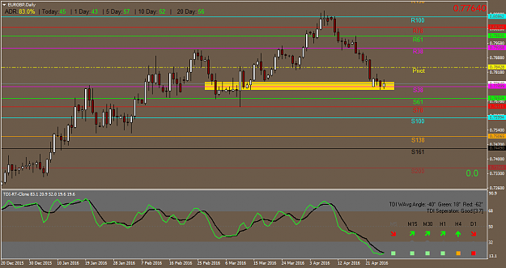
- Another trading G/U, price can’t break R78 (Resistance 78), and start move south, confirmed by TDI crossing.
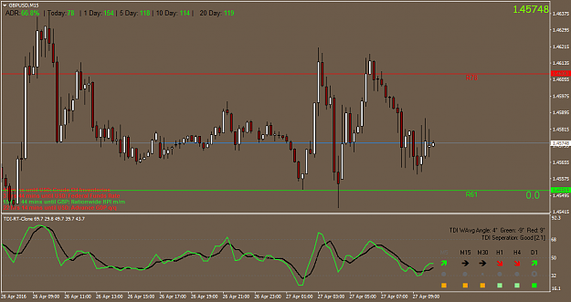
- TDI lines green crossing the black 15-30min chart and Price action agreeing. Its important to understand that pivots are zones and not exact number. Often price can fluctuate 10-20pips before turning. I trade UC a lot so here is a trade I gained over 300pips in 2 positions. Note price testing 100R again.
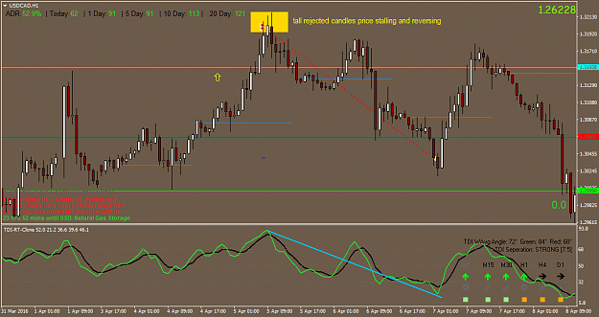

- Short EU, from R78 and confirmed by TDI
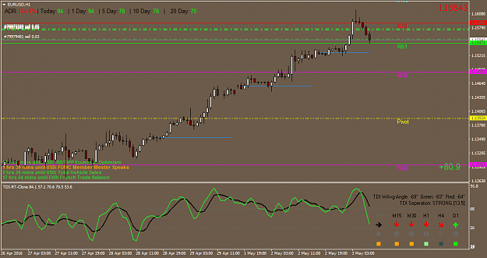

(Post #63) The 0.786 retracement is the square root of the 0.618. The 0.786 retracement is the next critical area to examine, after the 0.618 has been clearly violated. The 0.786 is a vital Fibonacci number because it is often the last chance reversal area before retesting the original price point. Price action that does not reverse from the 0.786 usually will retest, and often break past the original starting point. Therefore, 0.786 failures are significant because the stop loss limit will be clearly defined by the original starting point and relatively small in comparison to the potential reversal.
The 0.786 retracement is fairly unknown in the industry, although I believe that more technicians are becoming aware of its significance. In my opinion, it is a crucial Fibonacci number, since it is one of the last harmonic
ratios before retesting a trends prior high or low and it can provide a clear indication of the future direction based upon the price action at the number. Another reason the 0.786 is a valuable Fibonacci number is because it
can often gauge potential opportunities, especially when the surrounding market noise (information) suggests that the set-up is to be avoided. I have observed many situations, where the information in the media is quite
contrary to what the price action at the 0.786 is indicating. If a stock is trending strongly, the 0.786 projection frequently can serve as a key reversal point, despite such contrary information. The following illustrations and
examples will elucidate this concept."
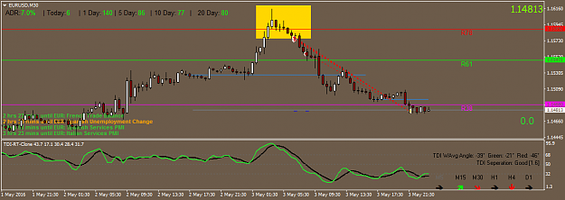
(Post #81)
Q: Hello, Davit! When you spot a setup at an important pivot level, do you go take a look at HTFs? Or you just take that setup, regardless of what the HTFs are saying, because you have complete faith in your PP system?
Price moves in waves look up Elliot Wave theory. Irregardless whether you trade EW or not price does not go straight up or down. I trade swings and they are swings on Down trend and uptrend. For me its all about the swing. Trend can change 100+pips in 4 hours opposite of previous 4 hrs and same on daily. Important to understand is where most turns likely to occur with the help of pivots and with TDI as confirmation you got a real edge. I have about 12 trades going now so there is no lack of opportunities.
My system is simple but complex same time. You must understand Price Action minimum.
(Post#117)
Q: 1.do you wait for setup to form on a higher time frame around the reversal zone like R61,R71,R100 then dig down to lower time frame to take the trade or when you spot a setup on any time frame like 30min you take it around the reversal zone. 2. I know you trade news do you trade before the news release of after the news release. if you are in a trade before a news release do you ride the news with the trade. 3.Do you look at divergent also when trading.
My base TF is 30min but when I see a weakness I jumped on it even on 15min but PA must be in good zone 61+ unless its ranging. Ranging pairs tend bounce from 38 to 38.
Its important to understand, I repeat that price action is important. TDI turn important because price can get through zones as we have seen on EA. Part of EA move was fueled by interest rate cut as well so there is fundamental drive behind.
I don't trade news. Prefer to be out most times specially NFP. One usually finds good opportunities after.
I do look for divergence but it has been my experience that its hard trading meaning what looks Div on H1 may look very normal on H4 and nothing at all on D. I like dives that show same up to Daily.
Its not something I put great importance. To me most important is looking at Price Action in zones.

(Post#135)
Q: Davit, thanks for your feedback, what in your opinion are good stable pairs to trade with plenty of good sized swings? I read about the fiasco a while ago with Swiss franc, and I can definitely see your point about the Japanese Govt interference in their currency ... (mind you - don't all Govts do that? ) I only decided to start with EU, GU, AU, EJ, UJ ,AJ, UCad as that was a recommendation for beginners on the TMS thread. I was going to concentrate on EUR/USD but I wanted to have a couple more alternatives for when that pair was flat,...
80% of my trades are on UC and some on AC and EC rest on EU AU NU GU EG. I like the Cad because I can keep up with oil and Cad fundamentals. To me you only need 2-3pairs to reach your monthly goal.
When you focus on few pairs you get to know it well and build confidence trading them. Its a misconception that one needs to be all over the place to make money. I can build 10 trades on UC equaling trading 10 different pairs but my results would be better because I only need one swing to collect.
General guidelines to me is this:
If you have less then 5years of experience then don't trade hyper crosses like GN GA EN GJ. Anything over 130 daily range is red herring to me. Its not about profits, its about controlling risk. Profits take care themselves.
Mistake lot of rookies make is getting carried over by greed and trade crosses and pay dearly when wrong.
Slow study the way to build equity.
(Post#171) Pivot trading is basically swing trading. We take profits from any swing irregardless of "trend" most here at FF don't understand what trend is. What they think trend most often are swings in range market.
70% forex is in a range. Traders often complain about "choppy markets" but seriously those are most profitable times. Focus on swings and that's when pivots help comes in.

(Post#233) ADR
Q: Hi Davit , I Read all the thread but i couldn't find how you take your positions , I am not talking about the first trade your are taking but the others so are you using the ADR for that ? which ration ? do you add positions just if you are in profit or if loss ( what the criteria ).
I follow PA once I am in, I build positions. I never enter full lot. Break them up and average out so I get a better price overall. This is common on stock trading but not in forex. Its my way of controlling losses. Should PA go against me I can get out with 1/4 lot damage instead of full lot. I don't place hard SL but do have a threshold when I get out. ADR is just allowing you to see daily extremes better. Example if UC travels 100 ADR last 20days and its at 110 then chances of correction is great. Usually late entries get crashed which in general is stupid money.
(Post#318) Multiple Entry (ME)
I treat My entries as badges as 1 trade consist of 4-6 average mini trades. When I exit I closed them all.
My average distance is 50-100pips which usually same distance PA travels from 1 pivot to another. When you look at the chart you know when to exit. My AN exit was 730 which was previous R and true enough did not break higher yet. To conclude watch the chart and behavior. If you want to educate yourself you can watch lots of videos on support and resistance online but frankly in general most are useless. Trading requires more. Think about this if trend lines S/R, MA cross overs, Overbought oversold oscillators was so obvious then how it happens that 95% traders lose in Forex. Answer is simple. They don't work. If majority of traders using typical technical analyses and lose then you must think outside of box.
ON ME I took the idea from a book called "Bird Watching in Lion Country" Not many understand this book properly. I thought it was a gem.
(Post#394) TDI
When TDI is sharp 4-5-6 O'clock, 12-1-2 O'clock means there is good buying and selling. This is something its intuitive you look at TDI wave and can tell what's going on. When its flattering means move is exhausted and ranging.
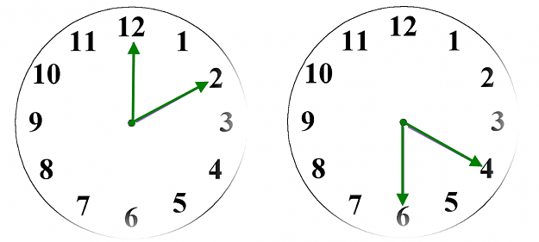

(Post#470) SL
Q: ​I do have one question: how do you manage your SL when you're not at your desk? I know you don't have a total pip value, more of a personable 'acceptable' DD %. As a swing trader, I'm assuming you sometimes keep positions open overnight or for a few days. How do you manage your SL then?
Once again my SL is based on actual $$ not pip. As long as my batch of trades have not reached max DD in terms of $$ then I let it run. Let me give you concrete example. I was shorting UC from 129 and price went 31+ and I had over 200pip DD but in actual $$ it was only 20% of my intended lot to be traded on this pair. Then I Hummered rest from the swing top and made all DD back plus nice profit. I trade unorthodox style
I learned over the years that 20-30pip SL is sucker move. It will get hit and you can be taken out even if direction is correct. I refined my style of trading that pivots allows best entries without huge DD. People who see the value of this thread will profit.
(Post#473) My SL is part of my trading entries. Should PA overrun my budget for that trade I take the loss manually. I often take earlier if I think fundamentals shifting. I work 70hrs a week and often can't be at my computer but twice a day morning and night I can hence plenty of opportunities to take the loss.
Reason I can do this because I don't over trade. I trade mini lots. Hope you are clearer. I don't talk about this often because I rather people use SL they are comfortable with.
(Post#612) I answered this multiple times here and may save it for future reference. I don't use traditional hard stops. I trade totally different them most traders. I use real actual $$ for stops and not pips. Example I like to short NU 7120. My budget for this is 2-3% of account risk say $500 for example. I then enter trades on mini lots and as long as my 500 is not consumed on DD and I am still confident of my trade I stay on it. I may choose to get out early but most times my SL is predetermined. This allows me to cast a wider net. So my 10mini lots can cover 50pip distance hence capture better RR. There is advantage to trade this way. Should PA go against you and you no longer like the trade you can get out by fraction of lot invested hence your loss is minimal instead of traditional 1 trade 1lot per trade when if wrong loss is substantially higher.
(Post#753) STOP LOSS:
1 Decide how much each swing is worth example $500
2. Divide $500 into mini lots for multiple entries example .50c a pip gives 1000 pip distance
3. This allows averaging in orders as seen fit irregardless if previous orders are in red
4. Orders are placed as long as reason for trade is still valid
5. If conditions change loss is taken since orders are not all placed all at once this allows smaller loss

(Post#552) General View
This applies to Nostro question and trading in general. First like to add that there is no loss system period!. If anyone is telling you there is one just stay away and don't waste your time.
Worth posting this:
Thinking in terms of probabilities also helps remove the emotional risk of trading. Mark Douglas talks about the 5 Fundamental Truths, they are as follows:
1. Anything can happen
2. You don’t need to know what is going to happen next in order to make money
3. There is a random distribution between wins and losses for any given set of variables that define an edge
4. An edge is nothing more than an indication of a higher probability of one thing happening over another
5. Every moment in the market is unique
Now my system is based upon simple observation that price hitting pivots away from weekly pivot will either break or retreat. That's my set of variables and given years of observation I came to conclude that price breaking 61R or 61S is less likely then going towards next level and rejection increases incrementally as price hits 78R/S and 100R/S. This is hard for people to get specially trend traders but simple fact is Elliot theory is real. Nothing goes in straight line. My system is based upon exploiting and profiting from swings. Its as simple as that.
To me trends don't exit only swings matter.

(Post#589) Daily Open & ADR
Daily open is S/R. It creates a bias. Its on my template for a reason. I always like to know DO and ADR distance from that line. If pair travels average 20days 72pips like NU and manages to travels 130pips in 1day from DO then probability of correction is great or you should be cautious of getting in on LATE party after the move is exhausted. I usually get in on beginning of the move rarely on tail end.

(Post#688) S/R 61 - 100
Just want to reiterate that space between 61R/S to 100R/S is most critical and volatile because most often price reverses on these levels hence spikes are common. So if I take a short or long at 61R/S I will most often stay in it even if it goes through it because I know they are 2 more greater S/R coming up.
Hope this helps in planning your SL and trades.

(Post#795) Demo & Real Acc
Can't do seminars not my style. I just share for benefit of others but you need screen time. Nothing can be substituted. Trading psychology takes time. You can have all the right knowledge. tools, methods and still lose because you may not have enough screen time experience to deal with your mind. Just spend time trading and things will start taking shape. Lot of what I do now is automatic....
If you can survive 1st- 2years without blowing accounts you have a shot in trading. Most traders start making money real money from 5th year+.Just takes time. When I look back shit mistakes I did from my rookie years I can't believe how much $$ I wasted (admin: me also :-p) . I guess it was a tuition money. Demo trading teaches little. Without having pressure on your mind with real money you won't grow as a trader. Everyone makes money on demo and brokers know that and that's why they lure new blood by making it look like you can do it with real money...Well most find out soon that's not the case. Don't demo at minimum trade penny amounts but enough that you care what you do. Train your mind.
(Post#953) This is one of the reasons I always push people to trade real money even if its just cents. The reason is metal conditioning. Demo does not provide that and dealers ,brokers know it and that's why they are eager to load 100k paper money to get you excited. Result is false sense of infallibility...which often ends up blowing a real account. To sum up trade small and systematic way and get out when wrong at reasonable level. What I mean reasonable level is example you started shorting at 78R and PA was correct and all of suddent some bank unloads big order price shoots to 100R. Now in this situation I will not exit as long as 100R remains unbroken. Majority of times price will start going down. Most times swings end with spike. This has lot to do with market orders, Usually when Bank A want to sell they won’t sell right away. They will push up 1st take stops which creates liquidity then drop their sell orders in chunks. This happens every day hence you should be aware spike in general does not necessarily mean trend continuation when at critical levels of 61;78; 100. Guys follow me? This is street smart trading. Got to see what your opponent is doing.

(Post#955) Correlation TDI & PA
Check out NU chart.Look at the spikes. Notice reversal followed by a spike. Typical trader might be thinking TDI up PA up arrows up lets buy! Nope! On my 1st post I highlighted in orange. Everything depends on location.
This is type of thinking rarely touched upon at FF or in books. Its hard putting your head around but location pivots create that key aspect in my trading because now I have a clear line on the sand to make appropriate decision. This thinking has Elliot wave theory as background guide. Pivots are nothing but waves. Price always travels in waves. Harmonics are based on EW and its real. As long as there is greed and fear markets will adhere to EW laws. This is why trend trading fails most times because trends go into corrections. Unless you can live with 10-20% DD, trend trading is difficult. Most retail accounts are not big enough to sustain trend's ups and downs. Anyway in my world trends don't exit only waves.
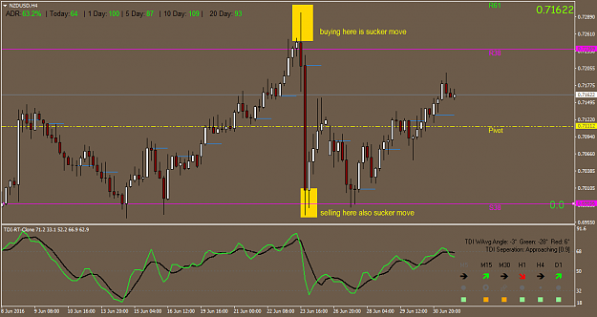

(Post#1068) NU
Here is an example what not to do. NU up going up like nuts. Don't sell just because you think its high. Sell when PA starts showing signs of decline and TDI starts pointing down. Look everything up. To me this could go.
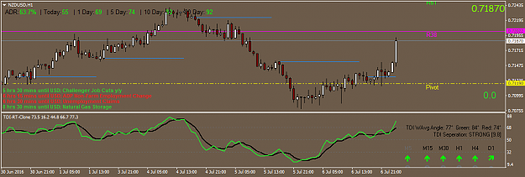

(Post#1073) Time Frame
Another thing you want to focus is this. Decide which TF you like the best. I like 30min the best and 15 min 2nd.
So when we say PA what context its relevancy. To me 30min price action TDI at pivots is sufficient entry. You decide what suits you This is actually very important. Your decision process. You can't waver from 5min to H4 or whatever. Decide 1 TF and base all your decision on it. When you frame PA this way things become clear like Divergence etc.

(Post#1103) NEWS
I follow major news events. That's why I have the calendar on my screen because it is that important.
Ex. tomorrow's NFP I rather stay on sidelines until after the news. Worst thing when you take a position without being aware find yourself in deep hole. I always read about Aussie, New Zealand Economies since I like trading them. Whatever you trade the most make an effort to get familiar fundamentals that is. Whoever said everything is in the price is simply being ignorant. That's the kind of BS (?) one reads over and over by people who basically are failed traders end up writing books about trading. Same goes for moving averages, overbought/ oversold oscillators crap. It makes sense right if you were selling and buying motorcycles for example wouldn't you want to know about the product thoroughly? Same example to anything that requires professional knowledge.
Short answer follow the news. You should have routine. Mark every major news on the whole week beginning of the week then form overview what may happen. That should be also done daily. You simply can't afford not to be in the "know".
(Post#1034) I learned to stay away from major news events. I may get lucky here or there but one is almost gambling. I did gamble for five years so trying to eliminate and I think I have that impulse totally from trading. My point is don't get hard wired in your brain that being live during major news events is good idea. In most cases market reaction can surprise you. I rather wait until market shows its hand. Series of bad trades can wipe out months of hard work. Number 1 goal is preservation of capital. Number 2 preservation of capital, number 3 preservation of capital. Can't stress this enough. Difference of professional trader vs amateur retail trader relies on this. Pros think about risk and act upon it. Amateurs think about profits mostly. There is a huge distinction.

(Post#1318) Divergence
Best you don't make decisions on trading from your experience level on divergence. Overused concept but very few understand it. You can see a Div on 15 min and 30min and nothing on H4 and Daily. All div is calculation based on Moving averages which most oscillators are based on. Does not mean price will do X because you saw a div on 30min. Most traders actually trade price action which corresponds with divergence. Its not leading indicator by any means.
Misinterpreting Divergence
Trading signals derived from divergence that are based on oscillator indicators can be difficult to read, and they are sometimes misleading. When the market is in a strong trend in either direction, oscillators do not function well. (OB OS levels) Any signs of divergence during a strong trend would be ambiguous at best. Divergence is best suited for confirming market moves and should be used in conjunction with other technical indicators and fundamental analysis.

